Day 13:
1)ER Diagram:
An Entity-Relationship Diagram (ERD) is a visual map that uses rectangles, ovals, and diamonds to show data objects, their properties, and how they connect in a database. Its main parts are entities, attributes, and relationships.

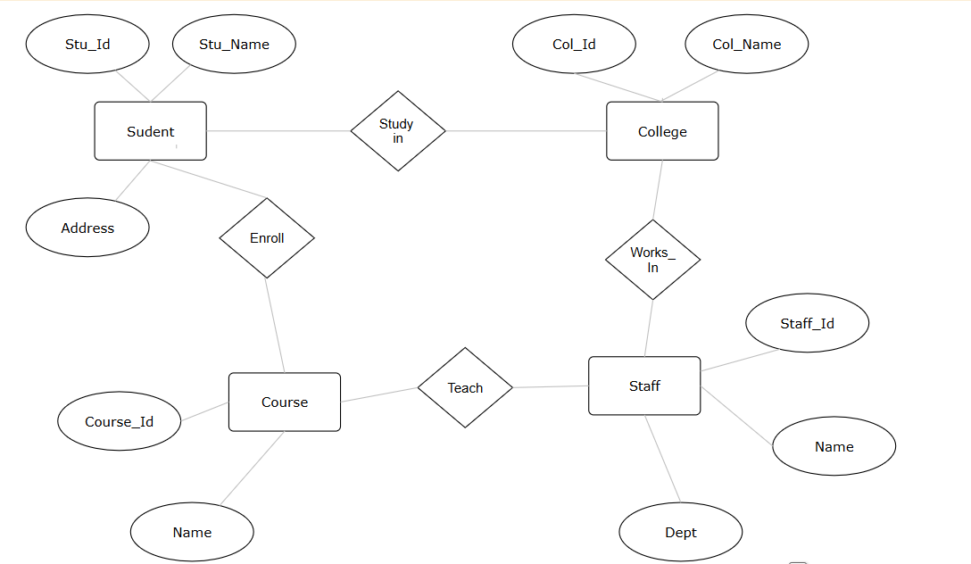

2)Indexing in DBMS:
It increases the retrieval speed of data from the database faster by use of Tree data structures.

3) Indexing improves query performance by minimizing the amount of data the database must scan to find a result, preventing a slow and resource-heavy full table scan.

4)ACID properties:
Atomicity-Every operation in a transaction should execute or nothing should get execute.
Consistency – The database moves from one valid state to another valid state.
Isolation – Concurrent transactions run separately without interrupting each other.
Duration-Data should be safe and consistent even if the system losses power or crashes.

5)Alter table <table_name> add column <new_column> <data_type> unique

6)Alter table <table_name> add constraint <constraint_name> check(<condition>)

7)Select * from <table_name> where <condition>

8)Select * from <table_name> Order by <column_name> asc|desc.

9)Select * from <table_name> limit 100; -> fetch only 100 records.

